**CLEAN CORE to GREEN CORE SAPATHON**

**Important URLs:**

**app:** <https://ep-cf-org-dev-app-app.cfapps.eu10-004.hana.ondemand.com/index.html#>

**git:** <https://github.ibm.com/nilay-ghosh/sap-greencomputing.git>

**CAPM:** <https://blogs.sap.com/2022/03/25/sap-capm-full-stack-ui5-application-with-crud-operations/>

**BTP Info:**

BTP subaccount name: **Subaccount: Evolution Partnership CF Subaccount - Overview**

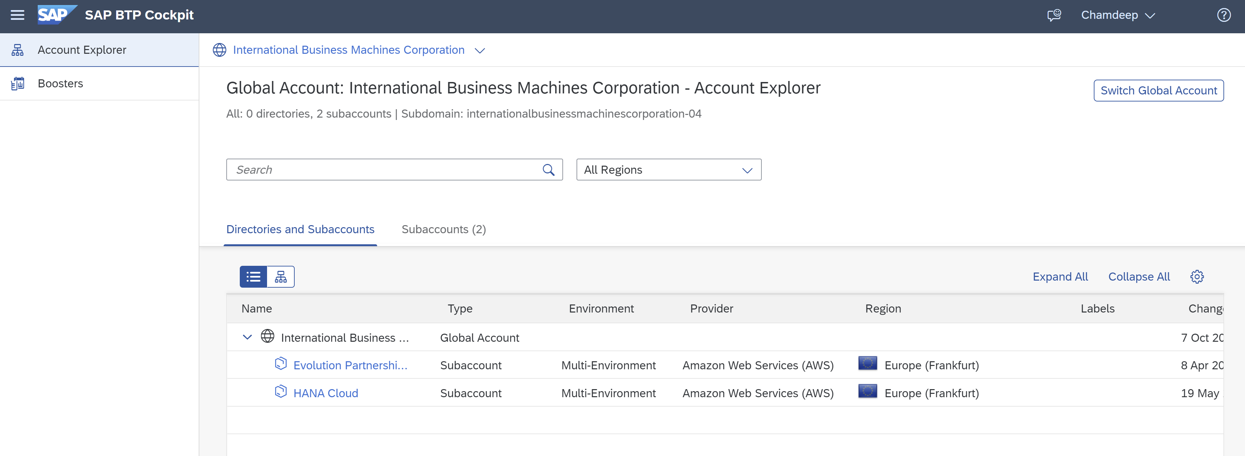

**DB Module:**

* Created table “**SampleTable**”.

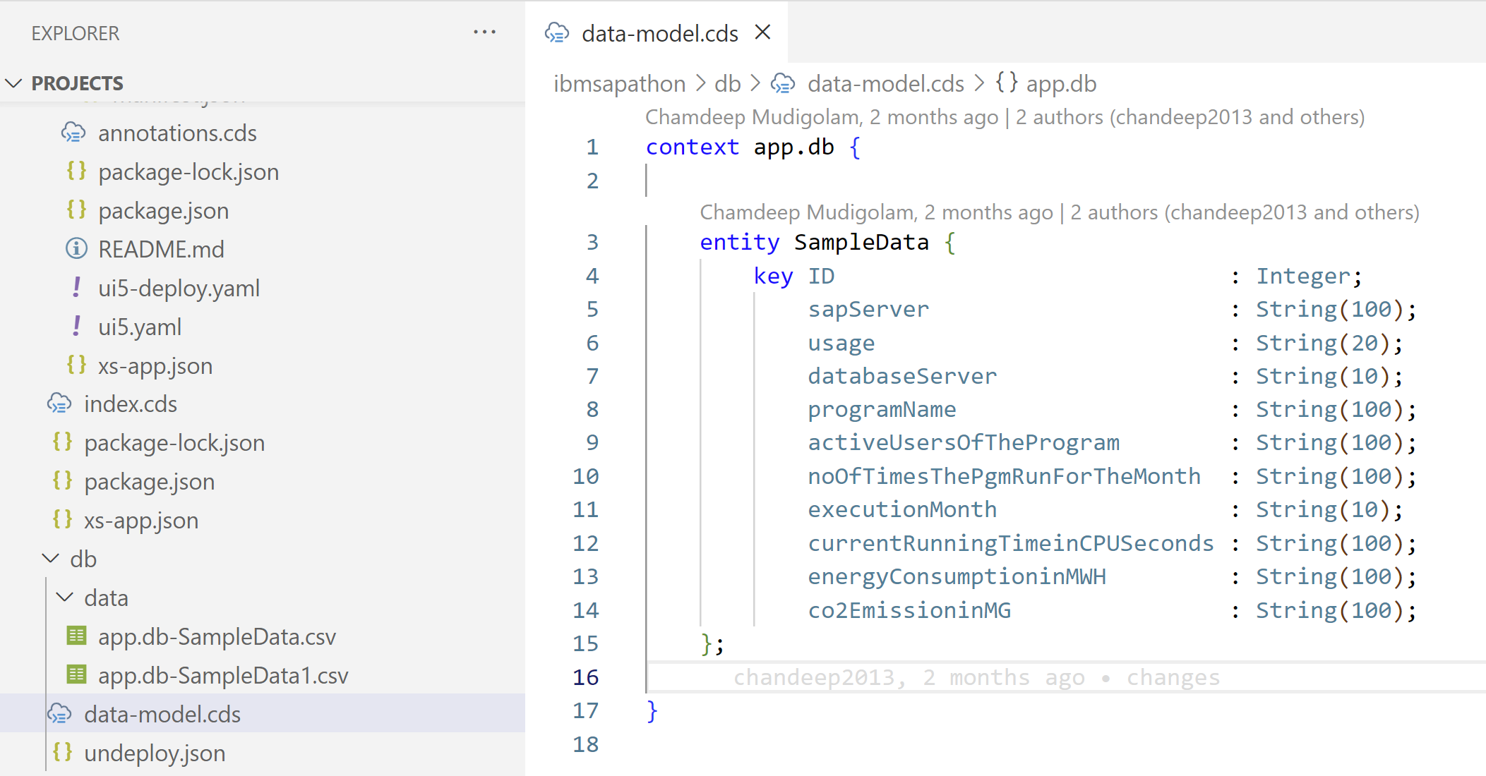

* Imported csv file in **db-data** folder.
* Naming standard need to be followed “ **Namespace.db-TableName.csv** “.

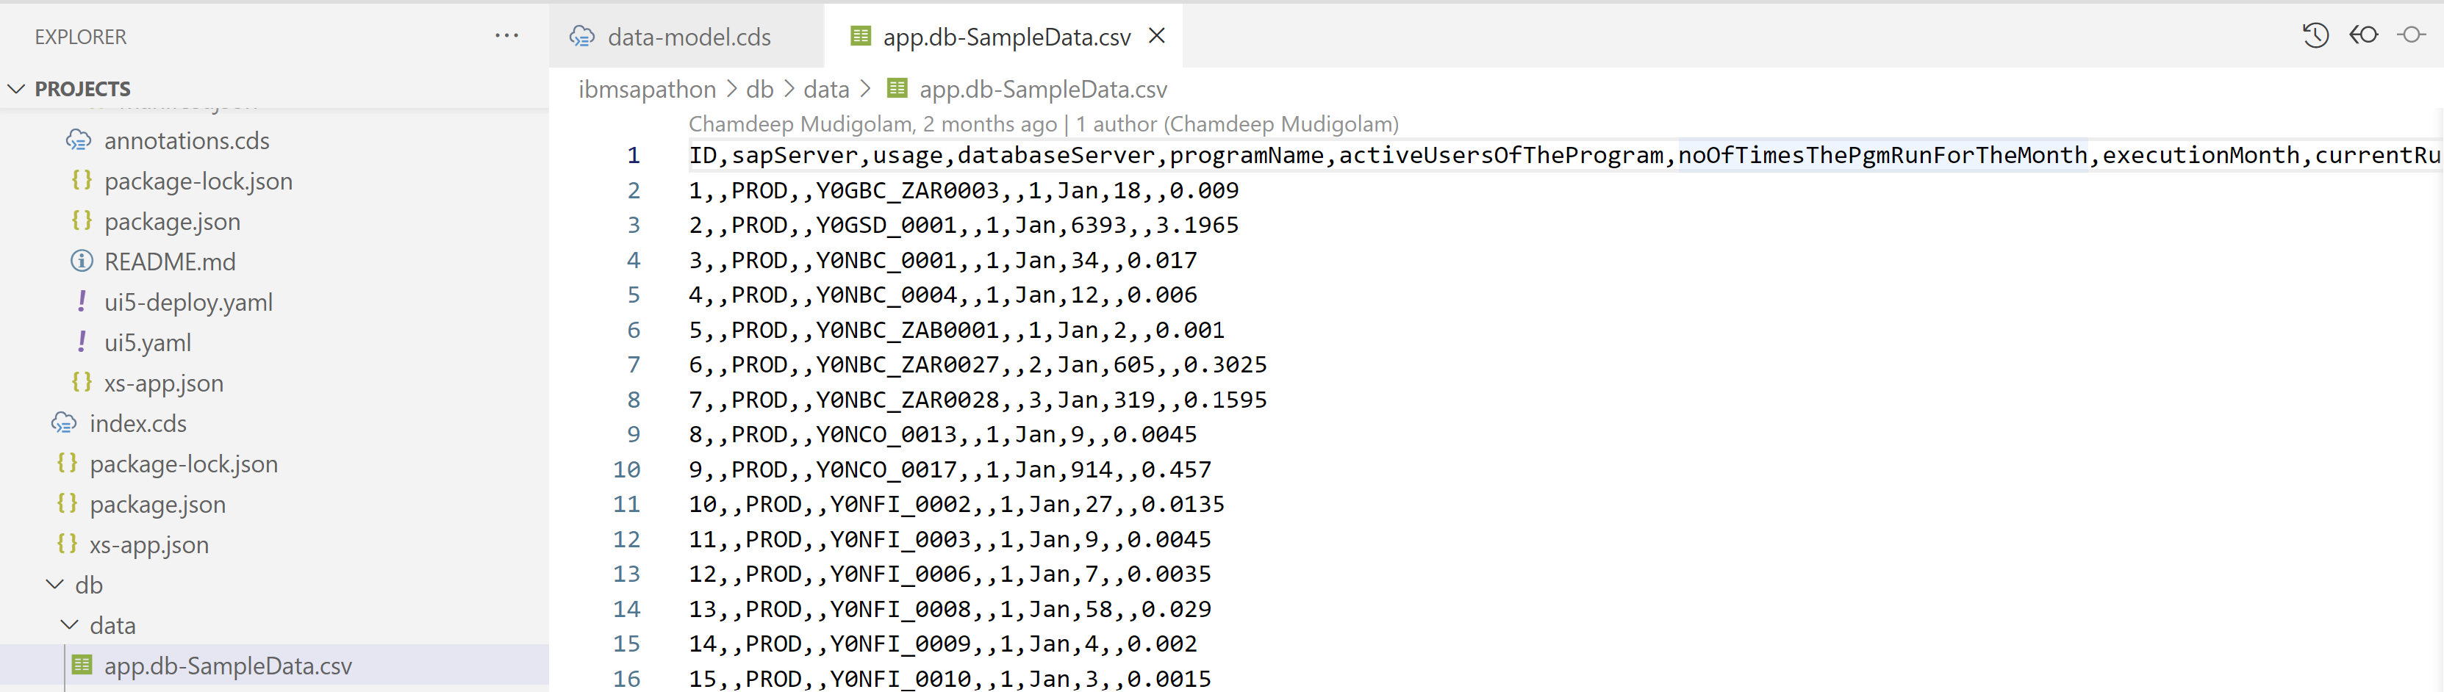

* In **package.json** file below code need to be added for creating **hdbtable** in hana db.

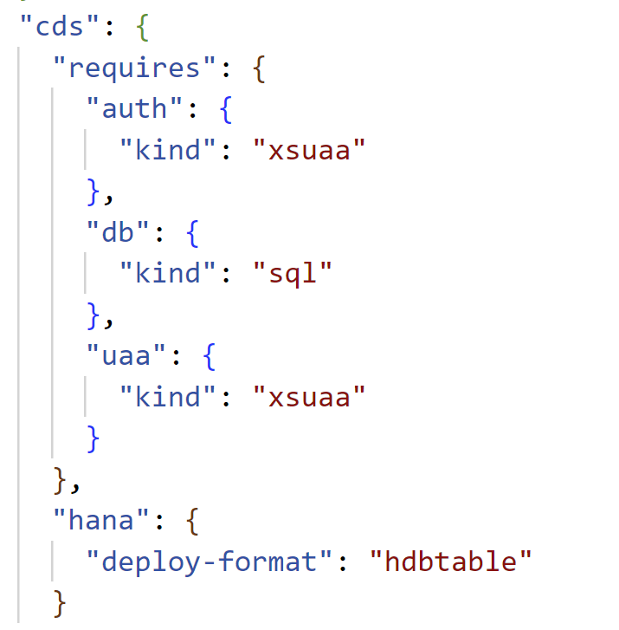

* DB need to be created in HANA Cloud.

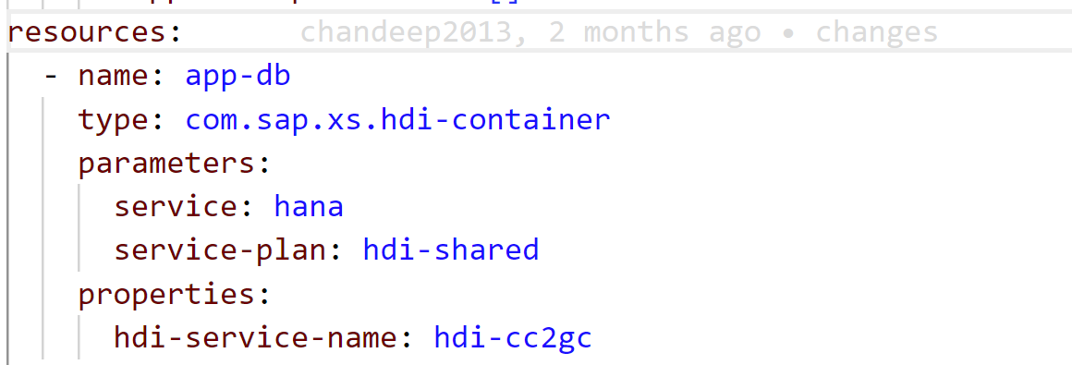

**SRV Module:**

* Created **CatelogService**

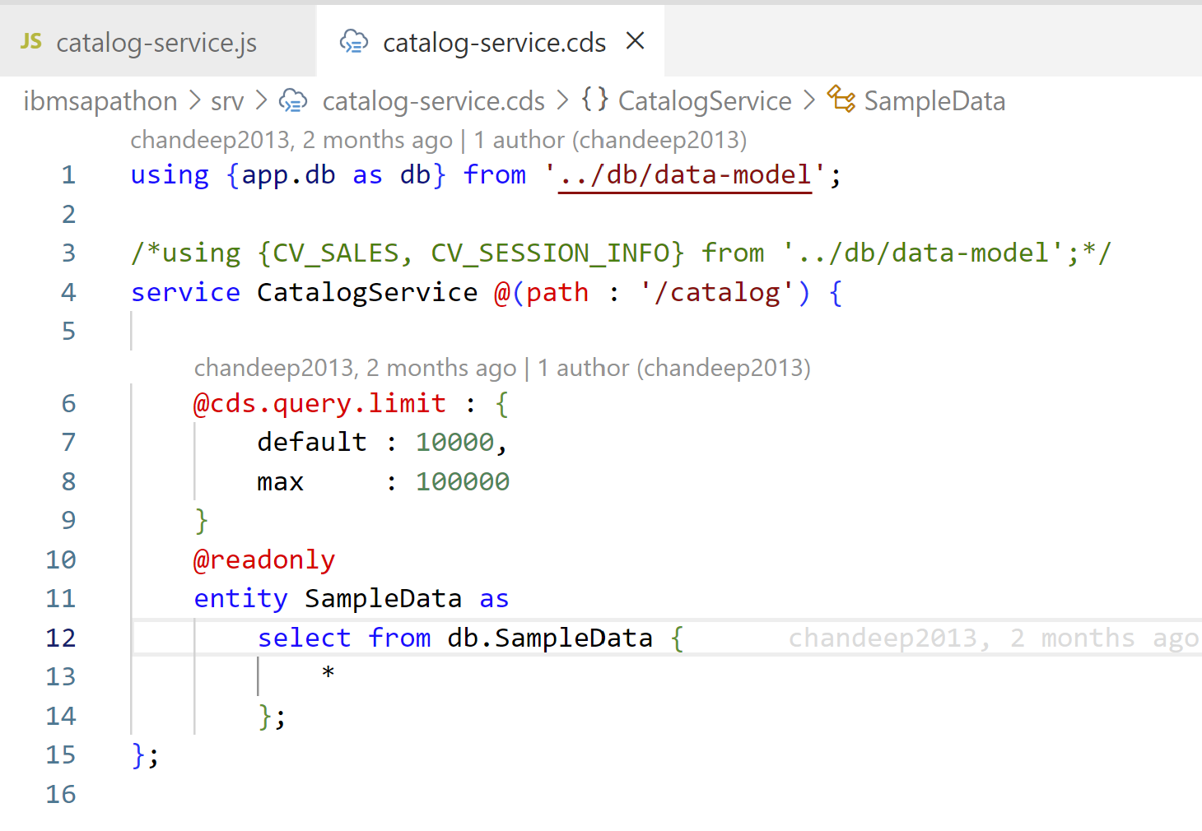

* Exporting **CatalogService**.

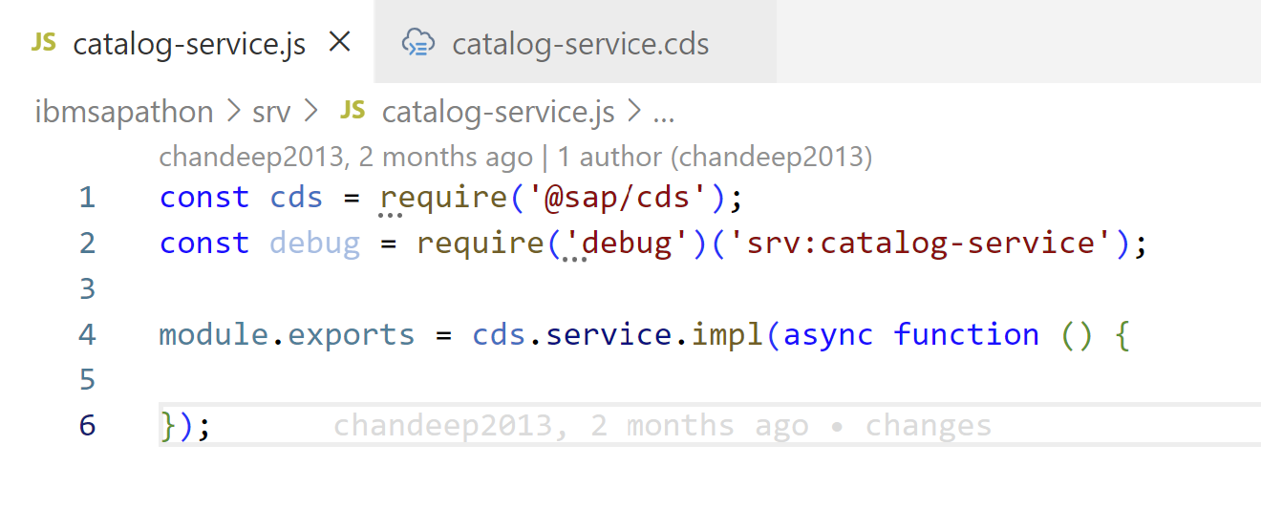

* Converting oData V4 to oData V2 version

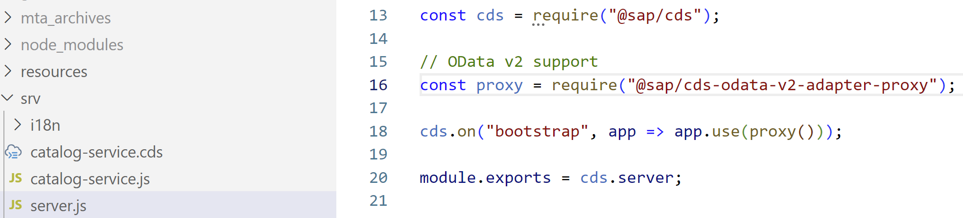

**App Module:**

* Created simple UI5 application.
* Service call sample

